Fixed-wing Lesson 2 Lift and Drag

[1. Introduction to Lift and Drag](https://classroom.udacity.com/nanodegrees/nd787/parts/ee7d5970-d39c-4355-952e-ce760e701827/modules/2dd61f74-6310-4f18-98b2-e4a9a9450f85/lessons/2354fbd4-eecb-4750-9590-29c2725c0db3/concepts/61296f27-6dd4-42a1-a053-55ea7f034c7b)

<https://www.youtube.com/watch?time_continue=16&v=KYbi95VDT1s>

[2. Physics Review](https://classroom.udacity.com/nanodegrees/nd787/parts/ee7d5970-d39c-4355-952e-ce760e701827/modules/2dd61f74-6310-4f18-98b2-e4a9a9450f85/lessons/2354fbd4-eecb-4750-9590-29c2725c0db3/concepts/86dd2891-b72e-4cfc-8429-35fcfb1aaf64)

# **Physics Review**

In flight, a fixed wing aircraft experiences four forces:

1. **Weight (W)**
2. **Thrust (T)**
3. **Lift (L)**
4. **Drag (D)**

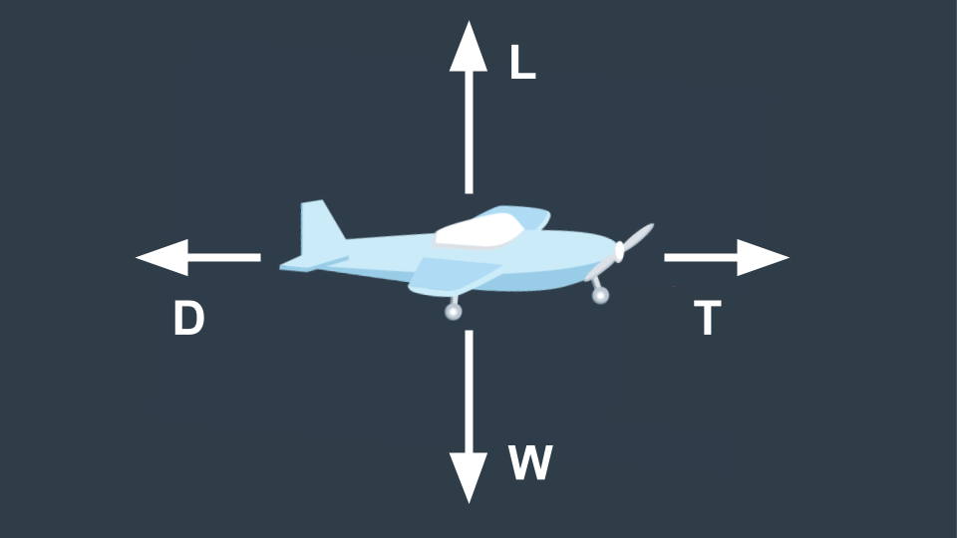

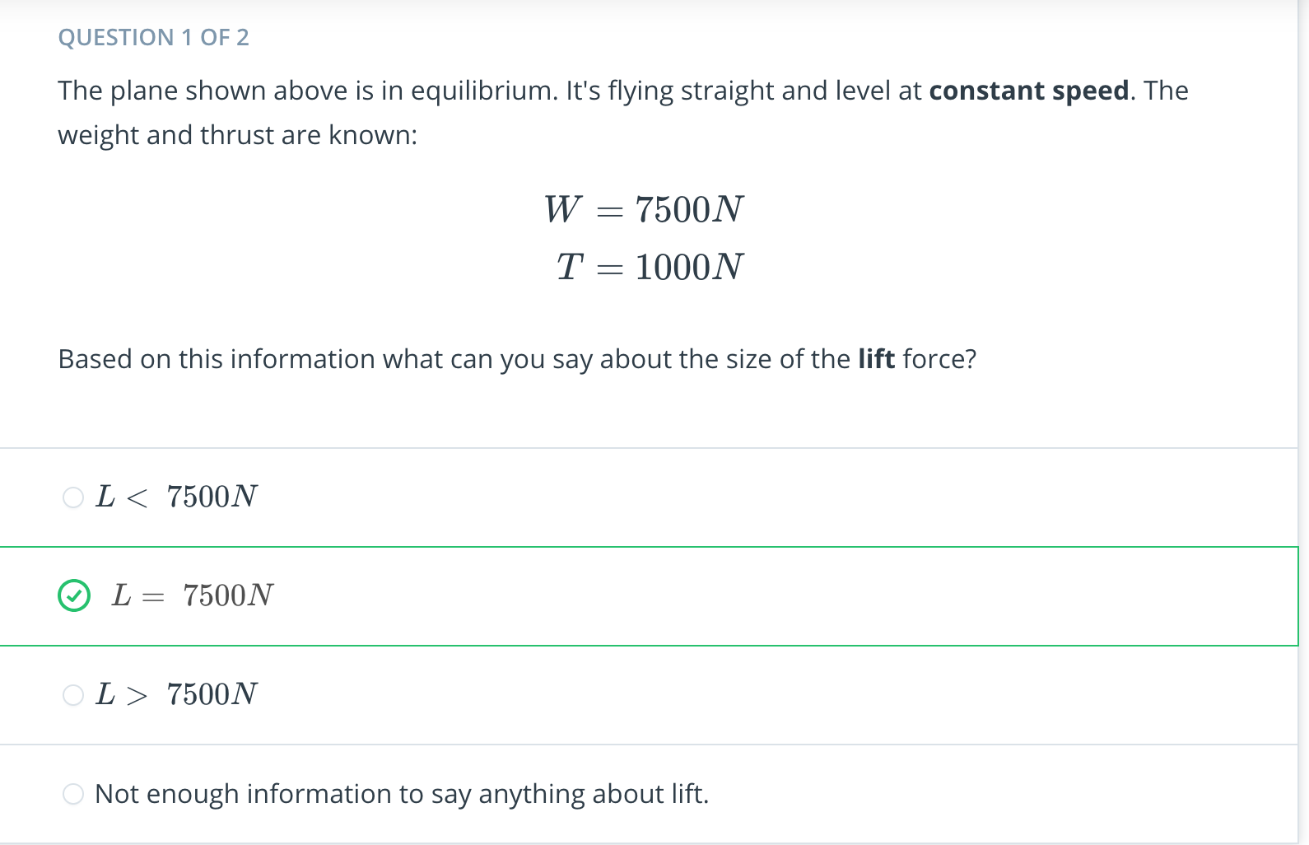

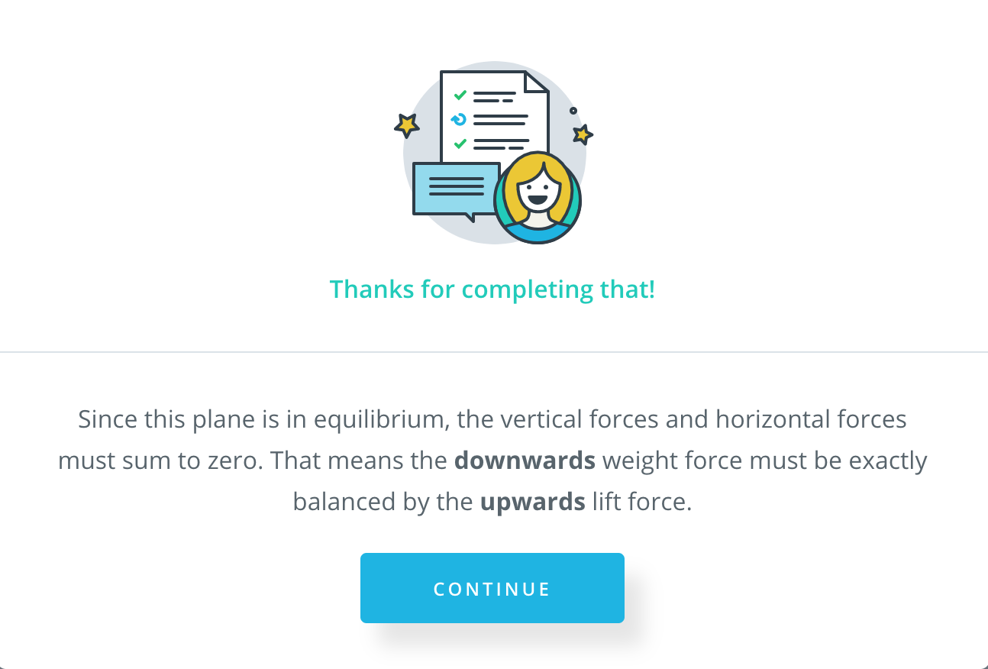

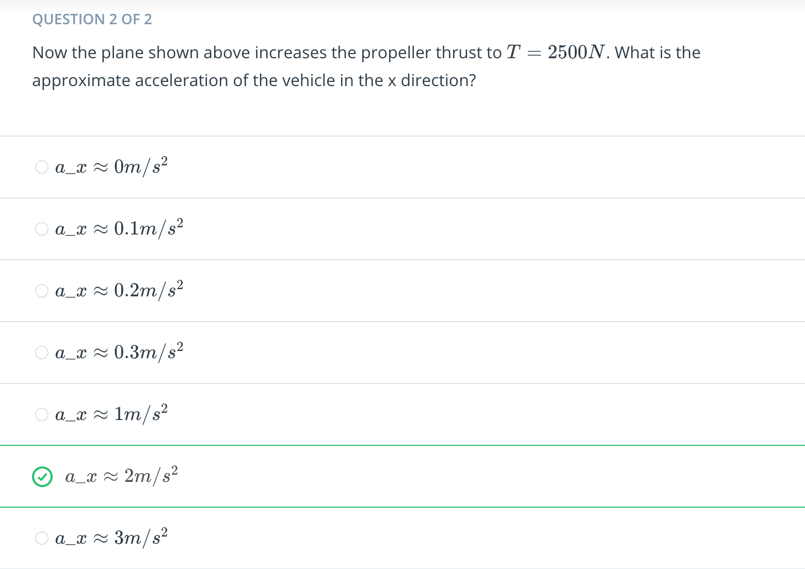

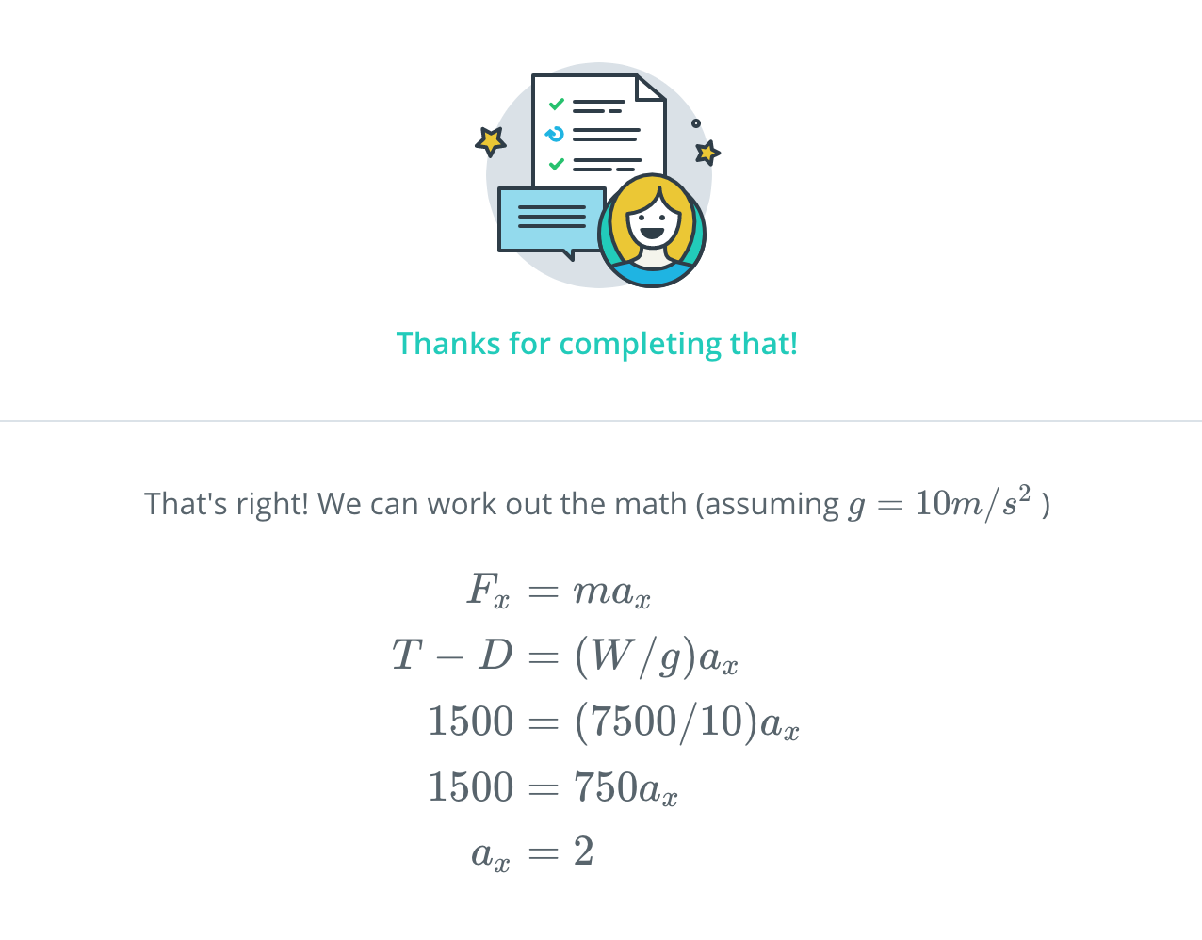

[3. Fixed Wing Dynamics: Longitudinal vs Lateral/Directional](https://classroom.udacity.com/nanodegrees/nd787/parts/ee7d5970-d39c-4355-952e-ce760e701827/modules/2dd61f74-6310-4f18-98b2-e4a9a9450f85/lessons/2354fbd4-eecb-4750-9590-29c2725c0db3/concepts/1990551f-d6d0-4ad1-adcf-2746c6c85c75)

<https://www.youtube.com/watch?v=k_sNlUyeNS0>

[4. Longitudinal Analysis 1](https://classroom.udacity.com/nanodegrees/nd787/parts/ee7d5970-d39c-4355-952e-ce760e701827/modules/2dd61f74-6310-4f18-98b2-e4a9a9450f85/lessons/2354fbd4-eecb-4750-9590-29c2725c0db3/concepts/8882aed1-2cb9-4a38-abbf-7f7f4a7dc9ca)

<https://www.youtube.com/watch?time_continue=1&v=Y2qxWFaWwt0>

[5. Longitudinal Analysis 2](https://classroom.udacity.com/nanodegrees/nd787/parts/ee7d5970-d39c-4355-952e-ce760e701827/modules/2dd61f74-6310-4f18-98b2-e4a9a9450f85/lessons/2354fbd4-eecb-4750-9590-29c2725c0db3/concepts/d40c7d93-f4d5-4e44-a4f5-19e44f54d175)

<https://www.youtube.com/watch?v=JU5iSi-RoAE>

[6. Frames of Reference Summary](https://classroom.udacity.com/nanodegrees/nd787/parts/ee7d5970-d39c-4355-952e-ce760e701827/modules/2dd61f74-6310-4f18-98b2-e4a9a9450f85/lessons/2354fbd4-eecb-4750-9590-29c2725c0db3/concepts/e170b459-6af7-44b1-817d-13ebb7ad9191)

# **Longitudinal Frames of Reference**

There are three frames of reference we care about when discussing longitudinal flight.

##### **1. Inertial Frame**

The inertial frame is just the N,E,D frame you've seen before. The origin is fixed relative to the earth and the x, y, and z axes point north, east, and down respectively.

##### **2. Body Frame**

The body frame is rigidly attached to the aircraft. The origin is the center of mass of the vehicle. The x axis points through the nose, the y axis points out over the right wing, and the z axis points down through the belly of the plane.

##### **3. Stability Frame**

The stability frame (or wind frame), is similar to the body frame: the origin is the center of mass and the y axis points out over the right wing. The x, and z axes differ.

The x axis points into the incoming airstream. The z-axis still points "downwards" but it's perpendicular to both the x and y axes, so it won't generally go directly through the belly of the plane.

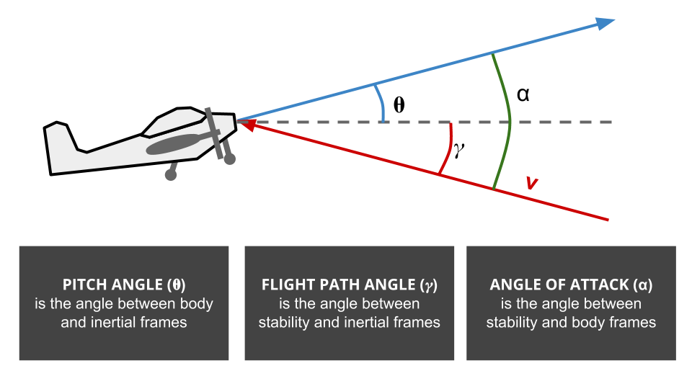

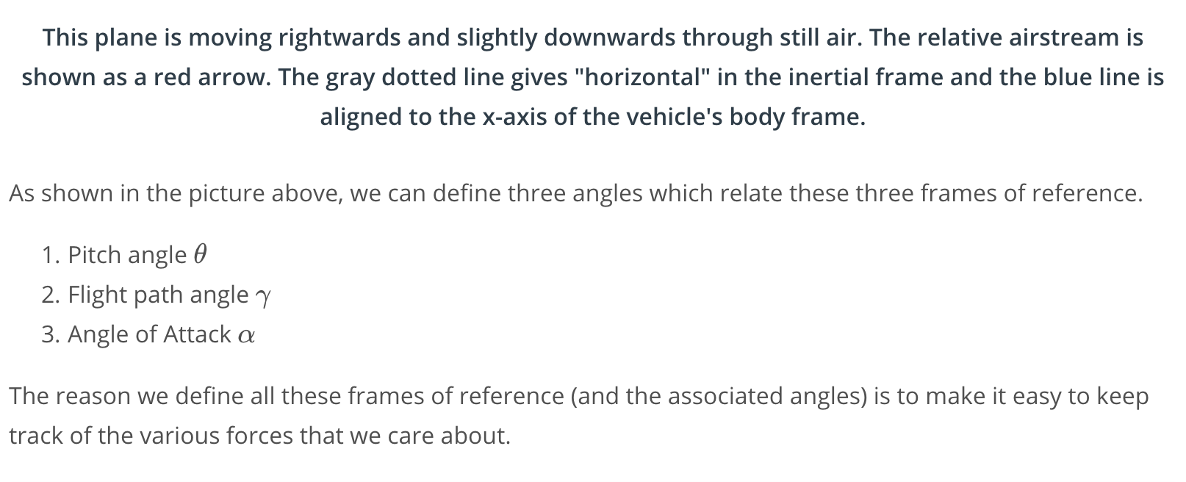

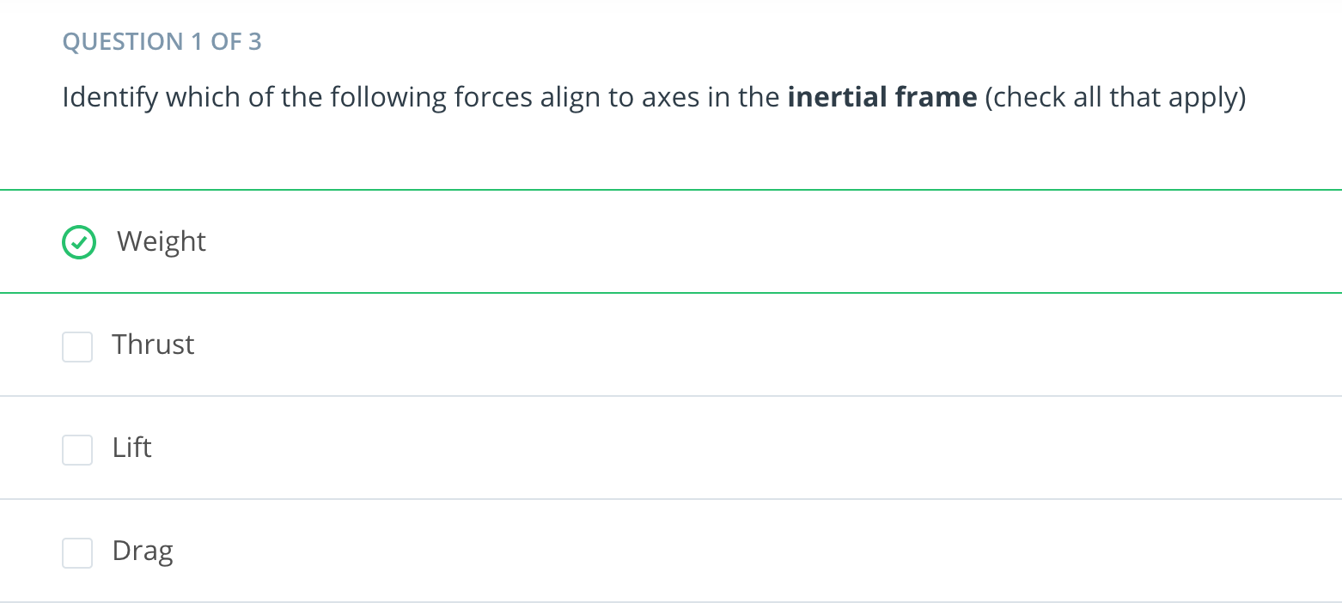



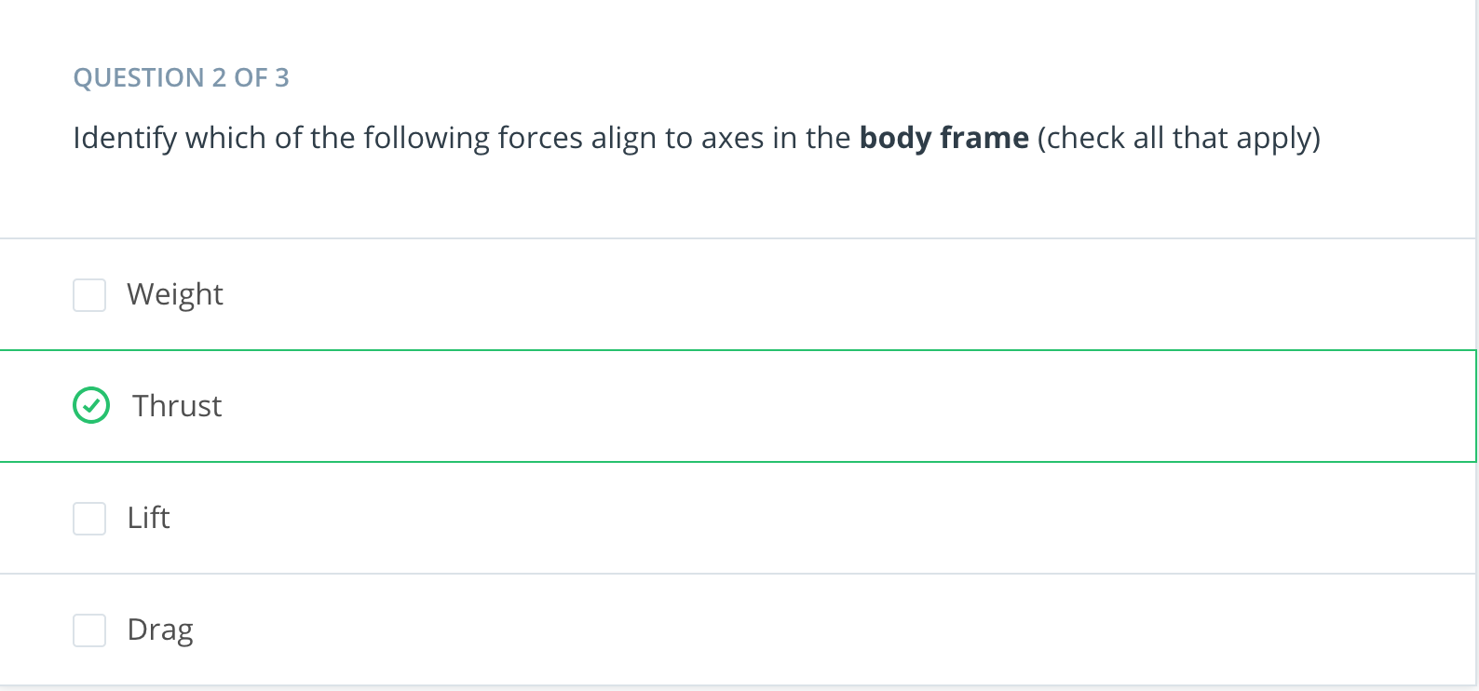



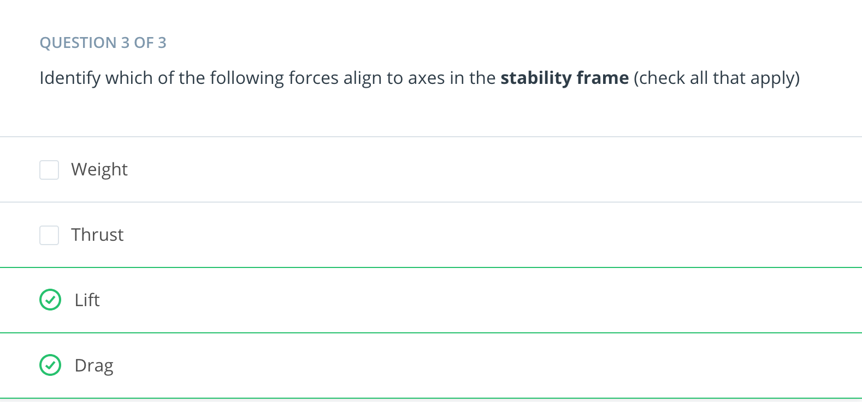



[7. Rotation Matrices Exercise](https://classroom.udacity.com/nanodegrees/nd787/parts/ee7d5970-d39c-4355-952e-ce760e701827/modules/2dd61f74-6310-4f18-98b2-e4a9a9450f85/lessons/2354fbd4-eecb-4750-9590-29c2725c0db3/concepts/b517a1a3-46ed-423c-84e5-a13d1f4bed90)

[Rotation matrixes-Student.ipynb](https://viewbjlfkffw7q.udacity-student-workspaces.com/notebooks/Rotation%20matrixes-Student.ipynb)

[8. Lift and Stall](https://classroom.udacity.com/nanodegrees/nd787/parts/ee7d5970-d39c-4355-952e-ce760e701827/modules/2dd61f74-6310-4f18-98b2-e4a9a9450f85/lessons/2354fbd4-eecb-4750-9590-29c2725c0db3/concepts/9d4939f9-da08-44c7-be74-7b4b62e72343)

<https://www.youtube.com/watch?time_continue=6&v=8iVgnZ0hrW4>

[9. Calculating Lift](https://classroom.udacity.com/nanodegrees/nd787/parts/ee7d5970-d39c-4355-952e-ce760e701827/modules/2dd61f74-6310-4f18-98b2-e4a9a9450f85/lessons/2354fbd4-eecb-4750-9590-29c2725c0db3/concepts/f5c2b4e1-4829-4a59-937c-cc93a54e4f8e)

<https://www.youtube.com/watch?v=I94_czCrWn0>

[10. Drag](https://classroom.udacity.com/nanodegrees/nd787/parts/ee7d5970-d39c-4355-952e-ce760e701827/modules/2dd61f74-6310-4f18-98b2-e4a9a9450f85/lessons/2354fbd4-eecb-4750-9590-29c2725c0db3/concepts/45110887-d8cc-43d5-906f-4e86b53bf70c)

<https://www.youtube.com/watch?v=WJp3-vrVVcM>

[11. Pitching](https://classroom.udacity.com/nanodegrees/nd787/parts/ee7d5970-d39c-4355-952e-ce760e701827/modules/2dd61f74-6310-4f18-98b2-e4a9a9450f85/lessons/2354fbd4-eecb-4750-9590-29c2725c0db3/concepts/0ea40a24-3394-47a9-b589-573f645dd6f7)

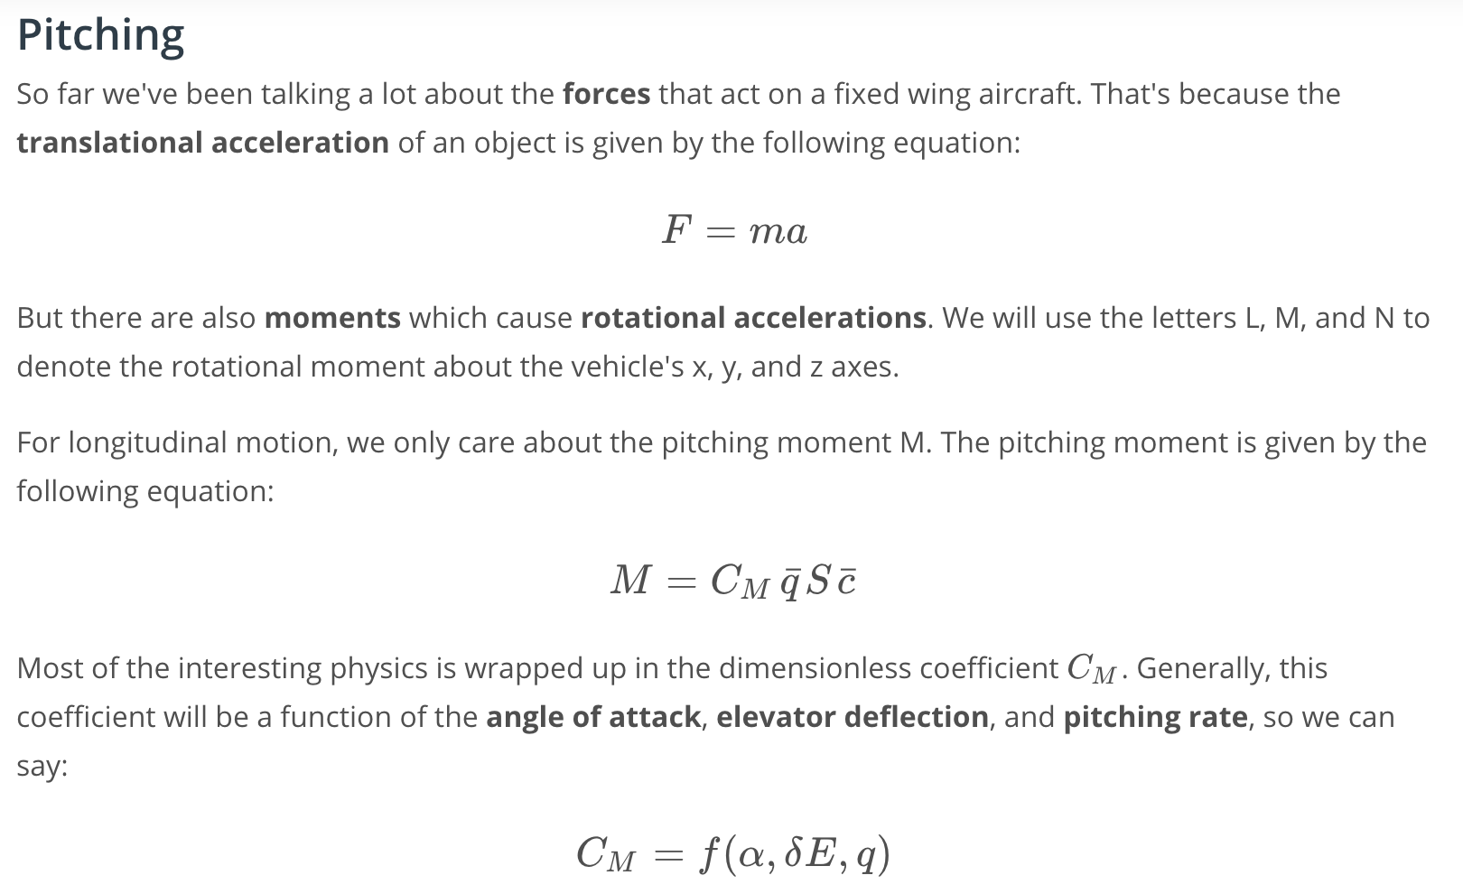

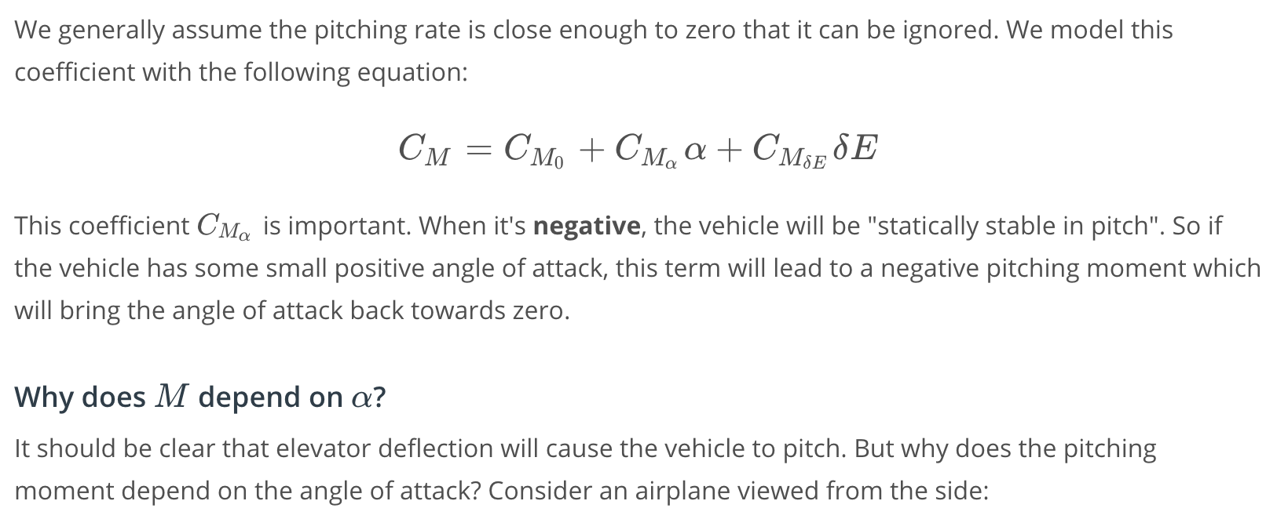

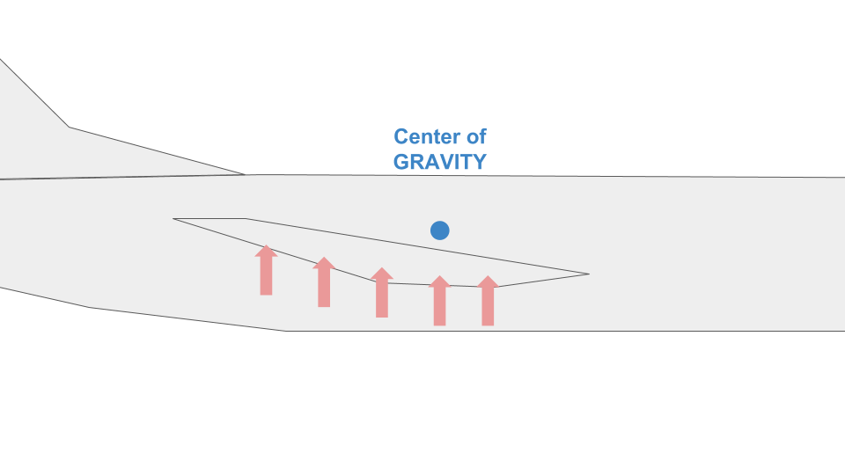

The center of gravity for this plane is located somewhere in the plane around where the wing meets the fuselage.

The red arrows show the effect of lift acting everywhere on the wing.

We can define something called the **center of pressure** and treat this distributed lift force as if it were acting at one point on the wing.

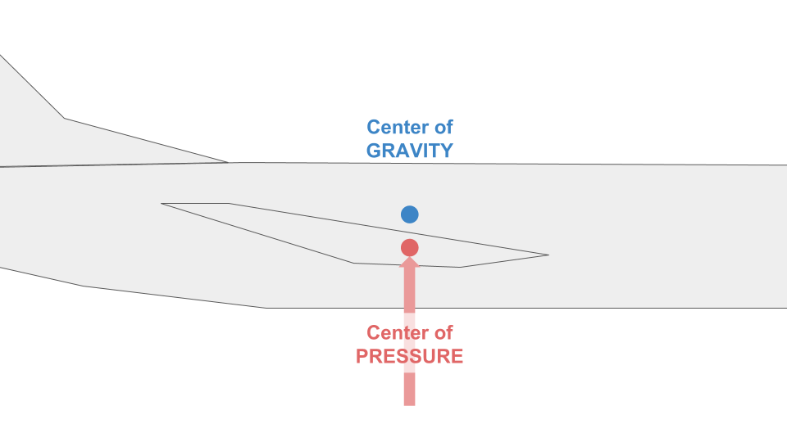

In this case (above), the center of pressure is directly below the center of gravity, so this will not produce any pitching moment clockwise or counter-clockwise.

But imagine if the center of pressure were shifted slightly forward on the wing:

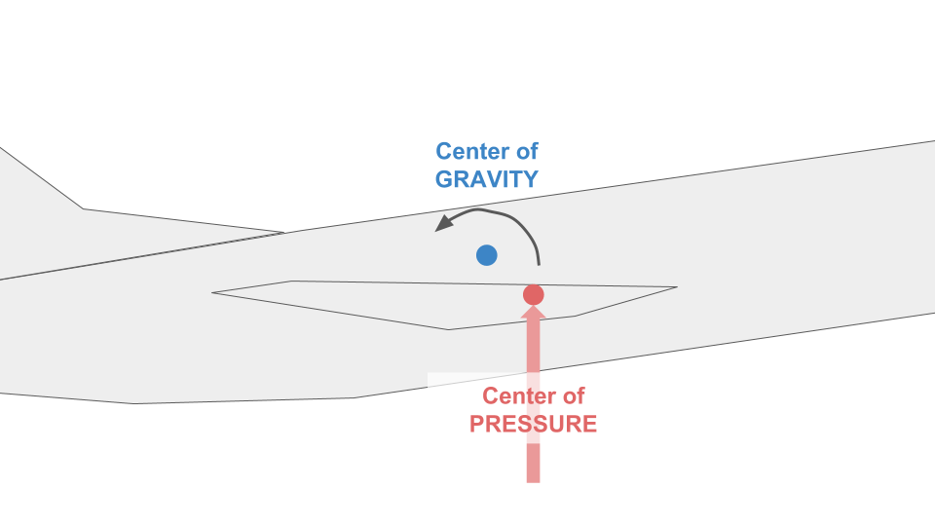

Now the upwards pressure will cause a rotation about the center of gravity.

And in fact, this is exactly what happens in real aircraft. As the aircraft's angle of attack (\alpha*α*) changes, the center of pressure will tend to move forwards and backwards along the wing.

It’s this motion of the center of pressure that explains why the pitching moment depends on the vehicle’s angle of attack.

[12. Trim States and Simplified Models](https://classroom.udacity.com/nanodegrees/nd787/parts/ee7d5970-d39c-4355-952e-ce760e701827/modules/2dd61f74-6310-4f18-98b2-e4a9a9450f85/lessons/2354fbd4-eecb-4750-9590-29c2725c0db3/concepts/befc3965-9f4d-43c3-b1c9-d399a93466c8)

<https://www.youtube.com/watch?v=ANXsAZ6ZuoI>

[13. Straight and Level Flight](https://classroom.udacity.com/nanodegrees/nd787/parts/ee7d5970-d39c-4355-952e-ce760e701827/modules/2dd61f74-6310-4f18-98b2-e4a9a9450f85/lessons/2354fbd4-eecb-4750-9590-29c2725c0db3/concepts/0dcd0b66-e473-4130-ac59-5719e2ae2de2)

# **Straight and Level Flight**

One important **trim state** is "straight and level flight". Straight means the vehicle isn't turning. Level means it's altitude isn't changing. Since it's a trim state, the speed is constant as well.

When a plane is cruising, we often want to fly straight-and-level *at a particular speed*. The questions we'll answer here are:

For a particular speed...

1. ... how much thrust does the propulsion system need to provide?
2. ... what angle of attack do we need to fly at?
3. ... what elevator deflection is required?

We can use the equations we've developed in this lesson to answer these questions.

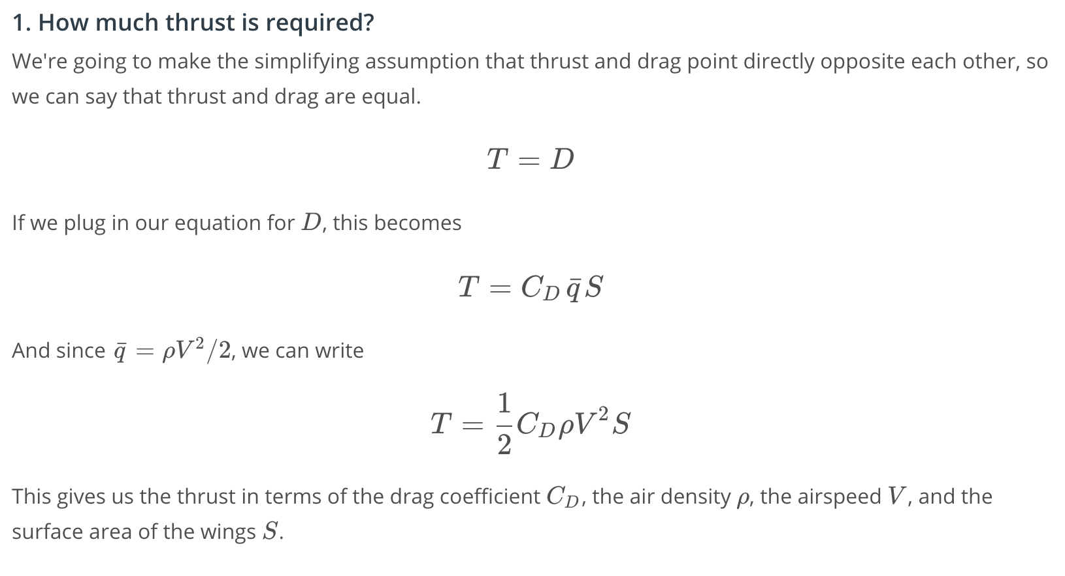

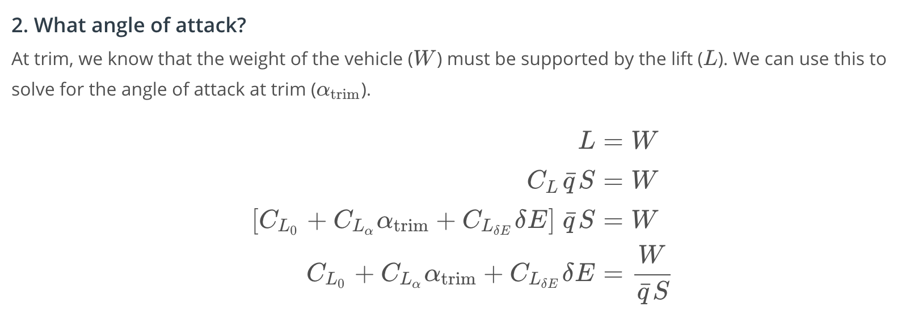

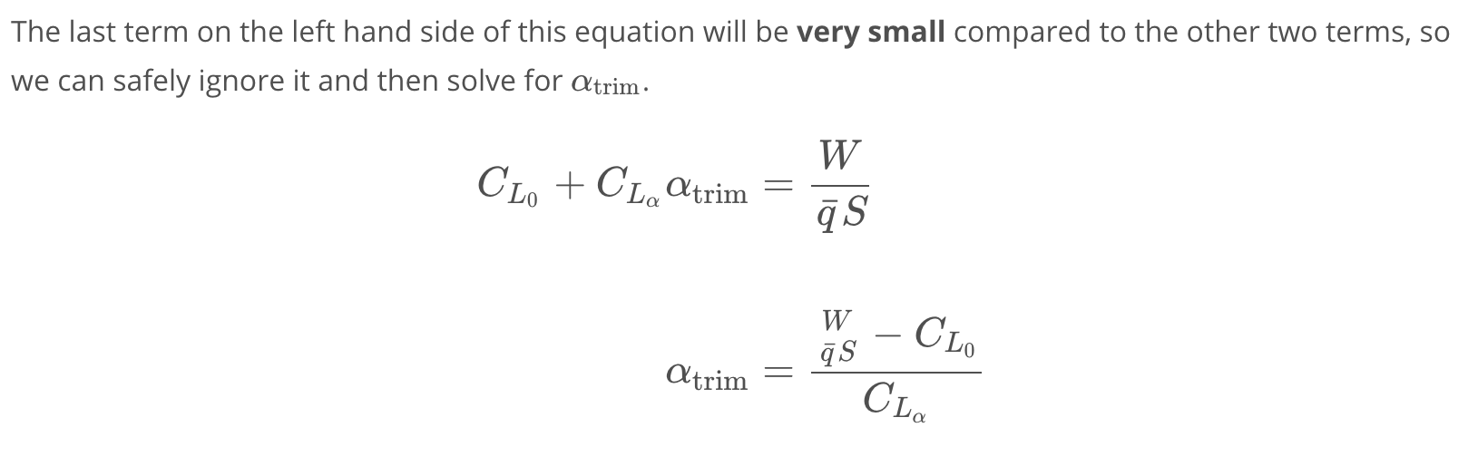

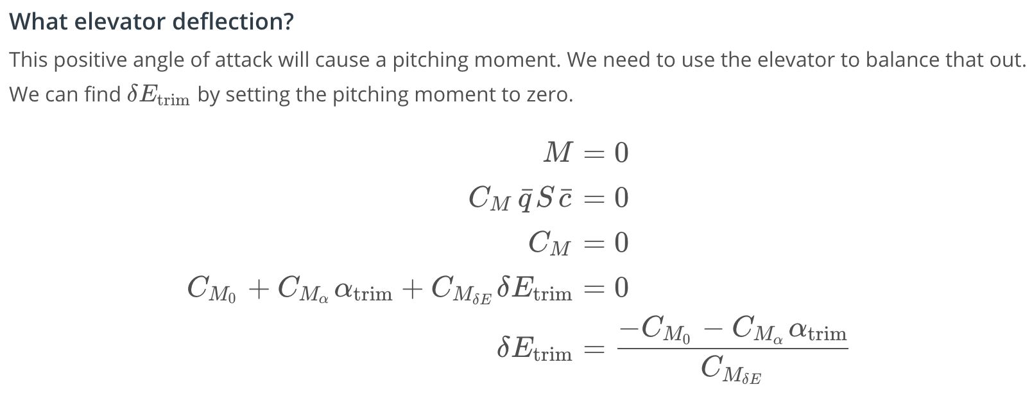

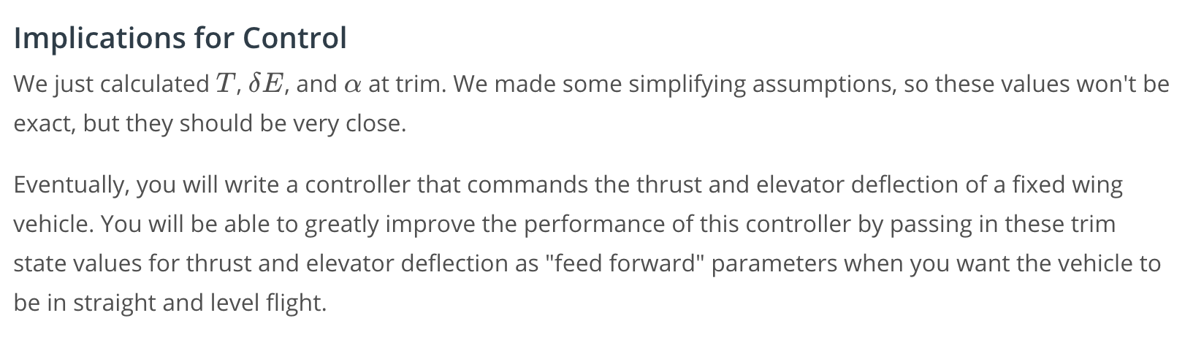

[14. Climbing Flight](https://classroom.udacity.com/nanodegrees/nd787/parts/ee7d5970-d39c-4355-952e-ce760e701827/modules/2dd61f74-6310-4f18-98b2-e4a9a9450f85/lessons/2354fbd4-eecb-4750-9590-29c2725c0db3/concepts/7d6cf754-b68a-4ed6-ae4d-2802280130f6)

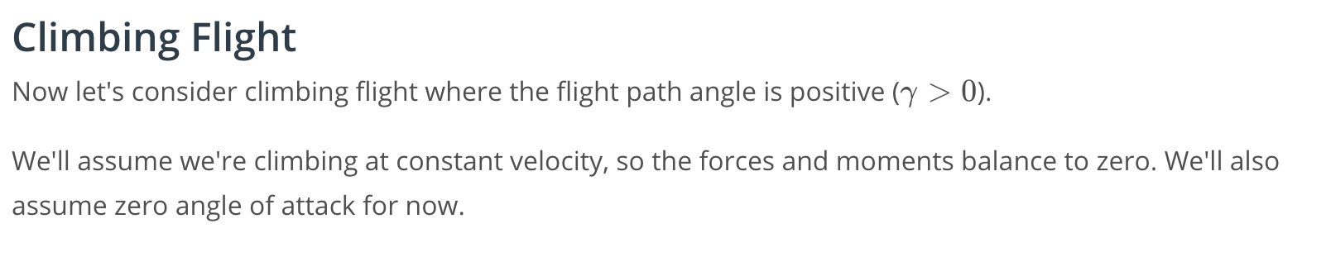

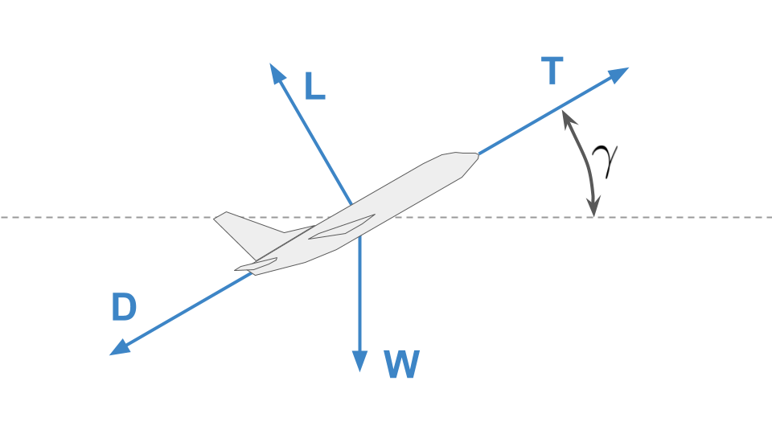

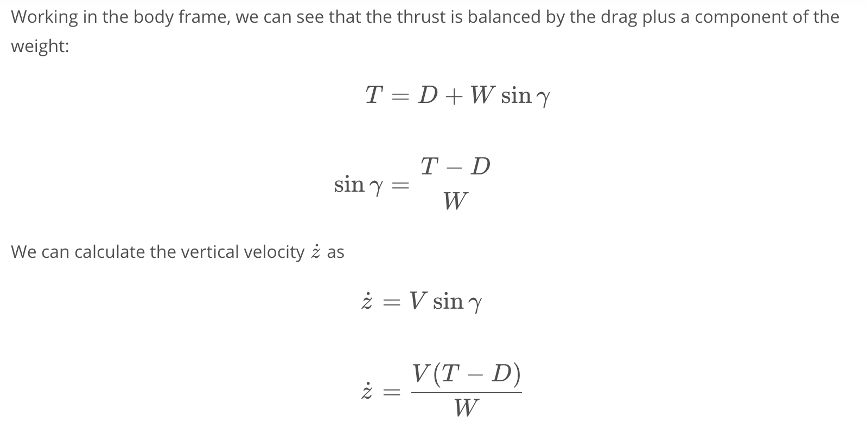

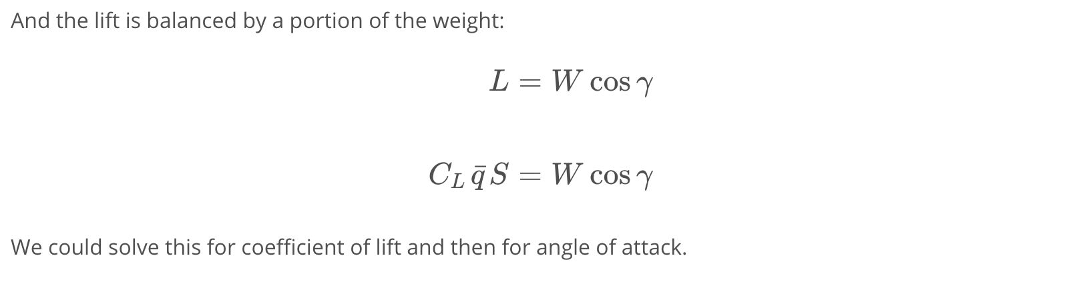

[15. Fixed Wing Cheat Sheet](https://classroom.udacity.com/nanodegrees/nd787/parts/ee7d5970-d39c-4355-952e-ce760e701827/modules/2dd61f74-6310-4f18-98b2-e4a9a9450f85/lessons/2354fbd4-eecb-4750-9590-29c2725c0db3/concepts/9fd5c72e-bbd1-4036-9bf1-9c13dd450ed2)

# **Fixed Wing Cheat Sheet**

You can find all of the equations that we'll discuss in this lesson and the 3 lessons that follow in the [Fixed Wing Cheat Sheet](https://www.overleaf.com/read/cvqmtzyhqjnj) that we have created.

We recommend you bookmark this resource (or print it out if you can) and keep it handy as you work on these lessons and the project that follows.

[16. Lift and Drag Exercise](https://classroom.udacity.com/nanodegrees/nd787/parts/ee7d5970-d39c-4355-952e-ce760e701827/modules/2dd61f74-6310-4f18-98b2-e4a9a9450f85/lessons/2354fbd4-eecb-4750-9590-29c2725c0db3/concepts/e44350d3-64b4-498b-8b95-893cd7cafa6a)

# **Lift and Drag Exercise**

This exercise [optional] gives you the chance to implement the equations you've seen in this lesson.

If you want to try implementing these equations yourself, open the file called Aerodynamics-Student.ipynb below. You might also find it helpful to open the .py files in new tabs as well.

Or you might just want to read through our implementation in Aerodynamics-Solution.ipynb

[Aerodynamics-Student.ipynb](https://viewsyl5zsfzxm.udacity-student-workspaces.com/notebooks/Aerodynamics-Student.ipynb)

[17. Conclusion](https://classroom.udacity.com/nanodegrees/nd787/parts/ee7d5970-d39c-4355-952e-ce760e701827/modules/2dd61f74-6310-4f18-98b2-e4a9a9450f85/lessons/2354fbd4-eecb-4750-9590-29c2725c0db3/concepts/6593d0eb-f616-43c1-9b4c-fc6587b90b2c)

<https://www.youtube.com/watch?v=DR7ObN2rBRs>